Web Development: Module 2, Lesson 7  
Developing React front-end Hands-On Lab

## Overview

Building on the [Module 2 Lesson 6 Lab](https://github.com/MSFTImagine/computerscience/tree/master/Complimentary%20Course%20Content/Module2/Labs), we will implement a front-end UI so users can see microposts on our microblog, add new posts and remove old posts .

## Objectives

In this hands-on lab you will learn how to:

* Implement a React front-end application which displays blog posts and allows for creation of new posts and deletion of old posts

## Prerequisites

The following are required to complete this hands-on lab:

* A code editor
* Windows PowerShell, Mac Terminal, or some other shell with node.js and npm installed
* You should have completed [Module 2 Lessons 1, 2, 3, 4, and 5](https://github.com/MSFTImagine/computerscience/tree/master/Complimentary%20Course%20Content/Module2/Lessons) as well as the [corresponding labs](https://github.com/MSFTImagine/computerscience/tree/master/Complimentary%20Course%20Content/Module2/Labs).

## Exercises

This hands-on lab includes the following exercises:

* Exercise 1: Developing React Front-end

## Exercise 1: Implementing a React Front-end

In this exercise, you will implement the front-end UI for a small blog using React. Note: Be sure to refer to the [Module 2 Lessons](https://github.com/MSFTImagine/computerscience/tree/master/Complimentary%20Course%20Content/Module2/Lessons) throughout this exercise.

1. Use [code/lesson7/Lab/package.json](https://github.com/MSFTImagine/computerscience/tree/master/Complimentary%20Course%20Content/Module2/code/lesson7/lab) to configure babel
2. Use [code/lesson7/Lab/package.json](https://github.com/MSFTImagine/computerscience/tree/master/Complimentary%20Course%20Content/Module2/code/lesson7/lab) and npm i to install: react, react-dom, babel-cli, babel-preset-es2015, and babel-preset-react
3. Implement React app (components/app.jsx) which fetches existing posts from the RESTful API using fetch, and shows them in a list
4. Implement functionality to send POST requests to create a new blog post
5. Implement functionality to send DELETE requests to remove blog posts
6. Use npm run build or npm run build-watch to compile JSX
7. Compare your solution with [code/lesson7/Lab/components/app.js](https://github.com/MSFTImagine/computerscience/tree/master/Complimentary%20Course%20Content/Module2/code/lesson7/lab/components)x.

The final solution will look similar to the screenshot below

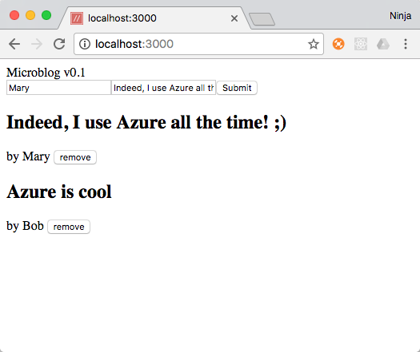

Creating and navigate to a new project folder

mkdir microblog

cd microblog

The project structure will look like this when we are done.

module-2-lesson-7-lab

/components

app.js

/node_modules

/public

/js

bundle.js

fetch.polyfill.js

index.html

app.js

app.test.js

package.json

README.md

start.sh

test.sh

Copy the files from the previous lab in which we created a REST API which uses Azure Table. We will build our front-end React interface on top of the RESTful API code. However, we will need to use additional dependencies including:

* Babel: to convert JSX (a special language for React) into JavaScript which will run in the browser.
* React: A front-end library for web User Interfaces

The package.json file you copied from the previous lab does NOT have all the dependencies we need. You can either copy package.json from the final source code for this lab and running npm i, or install the packages manually using this command:

npm i babel-cli@6.18.0 babel-preset-es2015@6.9.0 babel-preset-react@6.5.0 babel-core@6.18.2 -D

If you install the packages manually you also need to add a few configurations for Babel in package.json. Add the following lines which start with babel after devDependencies.

"devDependencies": {

"babel-cli": "^6.9.0",

"babel-preset-es2015": "^6.9.0",

"babel-preset-react": "^6.5.0",

"expect.js": "0.3.1",

"mocha": "2.5.3",

"superagent": "0.20.0"

},

"babel": {

"presets": [

"es2015",

"react"

]

}

In addition to the “test” and “start” which you already have from the previous project we will add two additional scripts to the package.json file:

* build - to compile JSX into regular JavaScript which we need to do in order to run our React code in the browser
* build-watch – to compile the code and stay running to monitor file changes. This is helpful during development because this way developers won't have to re-run the task over and over.

These new scripts use Babel command with --out-file and --watch options. Below is the updated package.json including these new scripts.

Note: source maps is a useful feature which allows you to see the JSX line numbers and code in DevTools and not the compiled code line numbers.

"scripts": {

"start": "sh start.sh",

"test": "sh test.sh",

"build": "./node_modules/.bin/babel components/app.jsx --out-file public/js/bundle.js --source-maps inline",

"build-watch": "./node_modules/.bin/babel components/app.jsx --watch --out-file public/js/bundle.js --source-maps inline"

},

Make sure it's valid JSON, i.e., you have all the commas and all the double quotes in the right place. If you experience any type of issues while manually enhancing the package.json file, refer to the final version in the source code for this lab for the correct code.

**Implementing React Component**

The source code for the browser script will be in components/app.jsx. The basic structure will be something like this:

"use strict";

let baseUrl = '/api'

let fD = ReactDOM.findDOMNode

let App = React.createClass({

getInitialState() {

return {posts: null} // Set the initial value to null

},

loadPosts() {

// Make a GET /posts request to the REST API to fetch existing posts

},

componentDidMount() {

this.loadPosts() // Call method to fetch posts from the back-end

},

render() {

// Render AddPost and PostList components with props

}

})

let AddPost = React.createClass({

handleSubmit(event) {

// Make a POST /posts request to the REST API to save a new post

},

render() {

// Render new post form with inputs

}

})

let PostList = React.createClass({

render() {

// Render list of posts (if any)

}

})

let Post = React.createClass({

removePost() {

// Make a DELETE request to REST API

},

render() {

// Render individual post view with a remove button

}

})

ReactDOM.render(<App/>, document.getElementById('app')) // Mount the main component

For AJAX/XHR requests to the server we will use the fetch API. If you have to support an old browser which does not support fetch API, then in the index.html include a polyfill to support the fetch functionality.

Set the mode to strict tells browsers we are using ES6/ES2015 syntax. Then, store the base URL to the REST API. In our case, it's hosted on the same domain so there's no need for the domain name. We'll use ReactDOM.findDOMNode more than once so it pays to save it in a short variable fD

Add the following code to your app.jsx file

"use strict";

let baseUrl = '/api'

let fD = ReactDOM.findDOMNode

After we create our main component App which has the logic to fetch the list of posts. We must initialize the state by setting it to some value like null. Fetching is triggered in the componentDidMount() lifecycle event which is executed when this component is mounted to the DOM of the page. In the render() method, we return two other components AddPost and PostList which we will implement later in this exercise. We pass the loadPosts() method as a property to AddPost so it can trigger the fetching of the posts upon addition of a new post. We do the same for the PostList. We also pass the list of posts to PostList.

Add the following code to your app.jsx file

let App = React.createClass({

getInitialState() {

return {posts: null}

},

loadPosts() {

fetch(baseUrl + '/posts')

.then((response) => {

return response.json() // The JSON payload is returned by the response.json() method

}).then((body) => {

this.setState({posts: body}) // Update the state and thus update the view

})

},

componentDidMount() {

this.loadPosts()

},

render() {

return (

<div>Microblog v0.1

<AddPost loadPosts={this.loadPosts}/>

<PostList posts={this.state.posts} loadPosts={this.loadPosts}></PostList>

</div>

)

}

})

Implement AddPost which has an event handler and the code to make a POST request as well as the form with inputs in its render().

Add the following code to your app.jsx file

let AddPost = React.createClass({

handleSubmit(event) {

event.preventDefault()

fetch(baseUrl + '/posts', {

method: 'POST',

headers: { // Set headers to ensure that the server interprets the content properly

'Accept': 'application/json',

'Content-Type': 'application/json'

},

body: JSON.stringify({ // Convert object to a string

author: fD(this.refs.author).value,

text: fD(this.refs.text).value,

})

}).then((response)=>{

this.props.loadPosts() // On response, trigger fetching of the list of posts

})

},

render() {

return (

<form onSubmit={this.handleSubmit}>

<input name="author" type="text" ref="author" placeholder="Peter"/>

<input name="text" type="text" ref="text" placeholder="I'm learning Node.js!"/ >

<input type="submit"/>

</form>

)

}

})

Immediately after AddPost, define PostList . It only one method render() in which it uses conditions to either show *Loading...* (when GET /posts request is being made), or *No posts yet* (when response has no posts). When rendering the list itself, we use map() with the key attribute for the Post component. Key will help React find a particular row faster. RowKey from Azure Table is what we use for unique value. The main post data such as author and text is not rendered here, but in Post.

Add the following code to your app.jsx file

let PostList = React.createClass({

render() {

if (this.props.posts == null) return <div>Loading...</div>

if (this.props.posts.length == 0) return <div>No posts yet</div>

return (

<div>

{this.props.posts.map((post)=>{

return <Post key={post.RowKey._} post={post} loadPosts={this.props.loadPosts}/>

})}

</div>

)

}

})

Finally, we need to implement an individual post component with a DELETE call to the API. In the render() function, it displays the post info such as author and text using Azure Table structure author._ and text._. The removal method is triggered by a click on the button due to the event handler onClick we define in the <button>.

Add the following code to your app.jsx file

let Post = React.createClass({

removePost() {

fetch(`${baseUrl}/posts/${this.props.post.RowKey._}`, {

method: 'DELETE',

headers: {

'Accept': 'application/json',

'Content-Type': 'application/json'

}}).then((response)=>{

console.log(response)

this.props.loadPosts()

})

},

render() {

let post = this.props.post

return <div><h2>{post.text._}</h2> by {post.author._} <button onClick={this.removePost}>remove</button></div>

}

})

ReactDOM.render(<App/>, document.getElementById('app'))

Before we run this app, we need to create an HTML file. Open Explorer or Finder or do it in your terminal / command prompt window. Create a folder named ‘public’ and then a folder ‘js’ as a subdirectory of ‘public.’ Put fetch.js into public/js. Now, create the file index.html in public.

Your index.html file needs a few script tags for React, React DOM and fetch polyfill. In the body create a <div> with ID app and a script tag which includes js/bundle.js. We don't create js/bundle.js manually because babel will do this for us when we run npm run build. As for React, ReactDOM and fetch polyfill (only for old browsers), you can download them on the web: [React](https://unpkg.com/react@15/dist/react.js), [ReactDOM](https://unpkg.com/react-dom@15/dist/react-dom.js) and [Fetch polyfill](https://github.com/github/fetch/blob/master/fetch.js).

Add the following code to your index.html file

<!DOCTYPE html>

<html>

<head>

<script src="js/react.js"></script>

<script src="js/react-dom.js"></script>

<script src="js/fetch.js"></script>

</head>

<body>

<div id="app"/>

<script src="js/bundle.js"></script>

</body>

</html>

We are almost ready to run the app. We need to tell our Express server to act as a web server for HTML, JS and CSS files, not just as a REST API. To do so, we apply static middleware: app.use(express.static('public')). In this statement, public is the folder which has our static files. Any file requested by a browser in that folder will be served to the browser. We don't need to do anything manually for index.html or for bundle.js since they are already in (or will be) in public. Let's apply this new middleware right after we create an instance of Express server by adding the following code inside app.js:

var app = express()

app.use(express.static('public'))

app.use(bodyParser.json())

Go to the terminal and run ***npm run build*** or ***npm run build-watch*** (recommended). You should see a newly created file js/bundle.js. If not, check for any errors in syntax.

Open a new terminal window and launch the server with ***npm start***. Go to http://localhost:3000 and you should see something similar to the screenshot below.

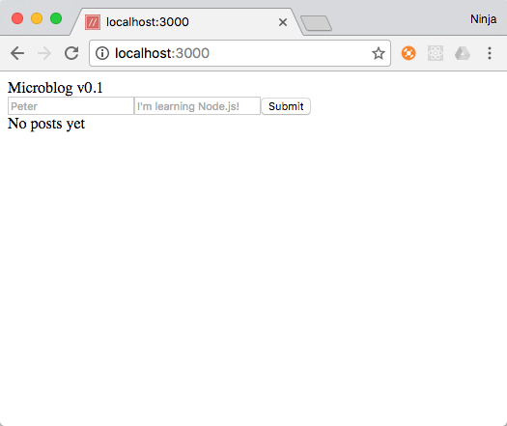

Add a new post. It should be saved in the database in the cloud and then appear on the screen similar to the screen shot below.

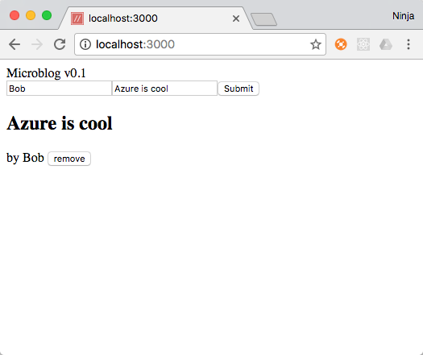

Remove your blog post to ensure the delete functionality works.

Congratulations! You built a full stack JavaScript app using Node, Express, React and Azure Tables as a persistent NoSQL cloud data storage.

## Summary

In this hands-on lab, you learned how to:

* Use React.js to implement the front-end for a simple blog
* Make AJAX/XHR requests to the REST API server
* Use Babel to transpile JSX to regular JavaScript